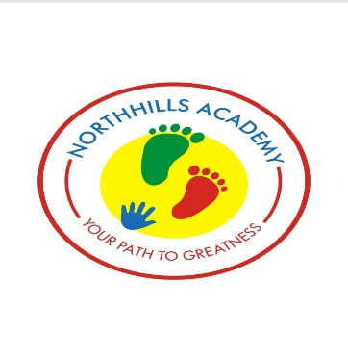
CLASS: Playgroup

SUBJECT: Understanding the world

WALT (What are we learning today): Shapes; Circle and Triangle

TERM: 2

WEEK: 6

TEACHER: Ms. Sarah
PREVIOUS KNOWLEDGE:
Animal rhymes.
ENTRY BEHAVIOUR:

The teacher promotes critical thinking by prompting pupils to draw conclusion based on visual evidence.

The teacher teaches songs related to the topic e.g shape songs.
LEARNING OBJECTIVES / OUTCOMES:

By the end of the lesson, children should be able to:
- Identify the shape circle
- Identify the shape triangle
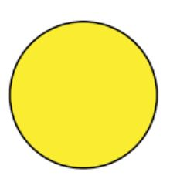
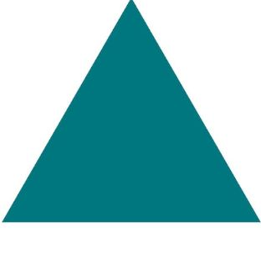

STUDENTS ENGAGEMENT: HANDS-ON ACTIVITIES

- Outdoor activities: Hop on and identify flashcards alongside the song introduced.
- Indoor activities: identify flashcards and concrete objects that links the topic (shapes)

RESOURCES/INTRUCTIONAL MATERIALS:
- Cd or tape player
- Pictures and concrete objects of shapes(circle/triangle)
- Videos
- Worksheets
- Blue tack or tape
- Colored crayons
- White board and marker
CROSS CURRICULAR LINKS:

Art, career, exploration, technology – database exploration

KEY VOCABULARIES: Shape, circle, triangle, identify.

CONTENT:

MILESTONES CHECK

LESSON DEVELOPMENT/ PRESENTATION
STEP 1: INTRODUCTION OF THE LESSON  Teacher’s Activity: 1. The teacher start the lesson by introducing a rhyme that links to the topic (shapes:heart/ star)  - The teacher begins the lesson by sitting the pupils in a circle and sings songs on shapes and encourage pupils to sing along, she further displays flashcards on shapes(circle,triangle). She says the name of the shapes and ask pupils to repeat after her.  Children’s Activity: 1. Pupils will be encouraged to repeats after the teacher. | 5 MINS
STEP 2: MODELING  Teacher’s Activity: The teacher shows the pupils the shapes(circle,triangle) for the pupils to touch and identify.  Children’s Activity: At this stage pupils all stands up to touch and feels the shapes( circle,triangle) | 10 mins
STEP 3: GUIDED PRACTICE  Teacher’s Activity: The teacher calls out pupils one after the other to mention the names of the shapes shown.  Children’s Activity: pupils are led to mention the names orally. | 5 mins
STEP 4: ACTIVITY  Teacher’s Activity: The teacher sets flash cards of shapes( circle/triangle) and asks the pupils to go pick up the flash card of any shape she mentions.  Children Activity: Pupils are led to pick up flash cards of shapes. | 15 mins
STEP 5: VOCABULARIES LEARNT  Teacher’s Activity: Sheep, star, heart, identify.  Children’s Activity: Encourage pupils to repeat after the teacher. | 5 mins
STEP 6 – CONCLUSION  Teacher’s Activity – Teacher reviews the lesson to ensure the pupils understood what has been taught.  Children’s Activity – Bring them back for review of the lesson. | 5 mins
EVALUATION  Teacher will ask the pupils the following questions.  Identify the following shapes.  Circle, Triangle. | 10 mins

