USMAN BISHIR ABUBAKAR
CURRICULUM VITAE
ADDRESS: Rahamawa Quarters, Katsina State.
E-mail: usmanbishirabubakar@gmail.com
GSM: 08103032398
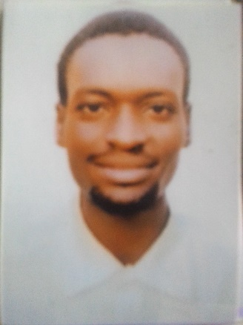
PERSONAL DATA
Date of birth: 12th October, 1995
State of Origin: Katsina
Local Government Area: Katsina
Sex: Male
Marital Status: Single
Religion: Islam
Nationality: Nigerian
Languages spoken: English/Hausa/Arabic

EDUCATIONAL BACKGROUND
- Danmarna Primary School, Katsina 2002 – 2008
- Sir Usman Nagogo College of Arabic and Islamic Studies 2008 – 2014
- Hassan Usman Katsina Polytechnic, Katsina 2017 – 2019

QUALIFICATION OBTAINED WITH DATES
- Primary School Certificate 2008
- Senior Secondary School certificate Examination Result (NECO) 2014
- National Diploma Library and Information Science 2019

WORKING EXPERIENCE
- Teaching at Umar Bn Khadab Abbatuwa Katsina 2018 – to date
- Mailafiya Furniture’s 2014 – to date
- Akbar Reliance and Enterprises 2019 – 2020
OTHER CERTIFICATE OBTAINED
- Certificate in Computer Application/Appreciation 2017
- Entrepreneurship Training Certificate (Electrical Installation) 2019
- Computer Hardware and Smart Phone Certificate 2021
- Jobberman Skill Certificate 2021
- Honor Award as Best Performing Teacher 2022

HOBBIES
Reading, Research and Travelling

REFEREES
- NURA ABBA UNGUWAR ALKALI
Head of Department, Department of Library and Information Science,
Hassan Usman Katsina Polytechnic, Katsina State.
08032467172

- BARR. FALALU ABBA IMAM
Faculty of Law,
Umaru Musa Yar’adua University Katsina
08036852555

- DR. SULAIMAN MUSA GANI
Director Pure Tech Scientific NIG. LTD
08169714661

