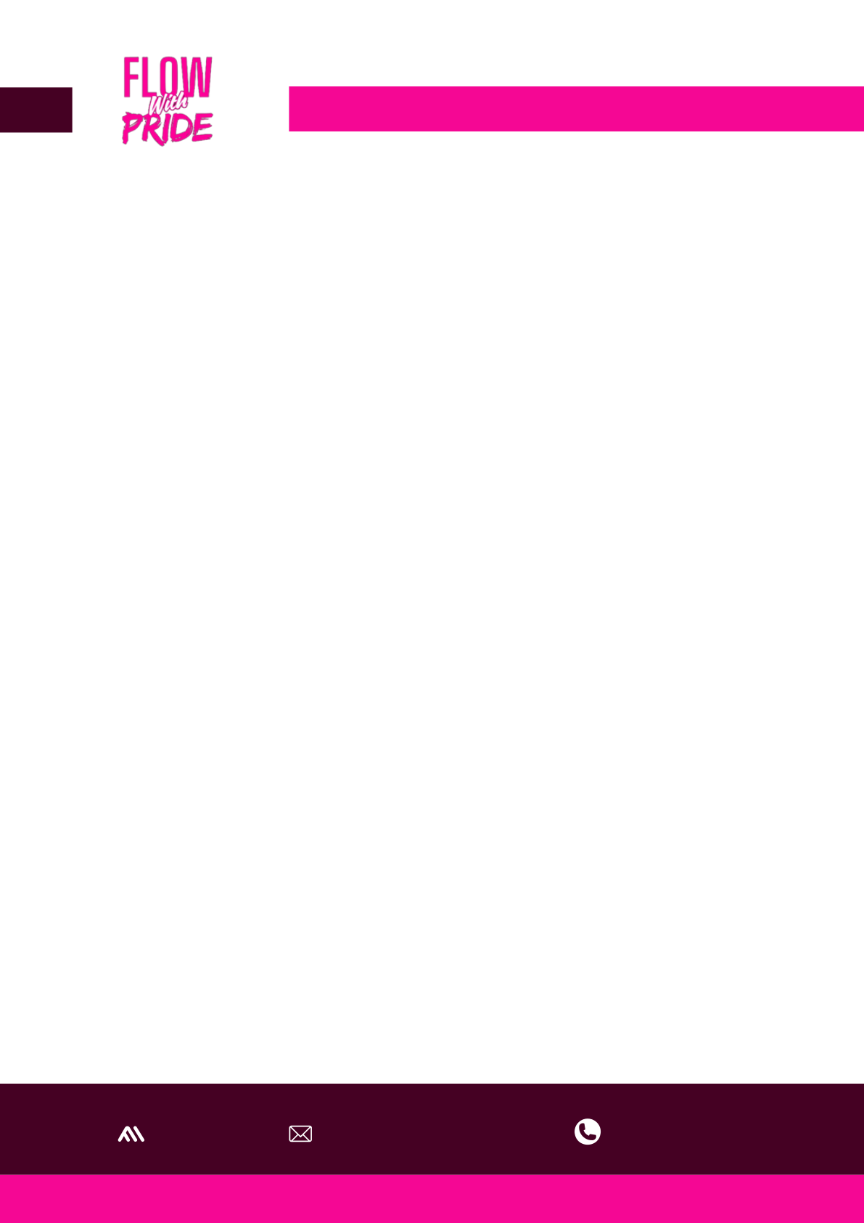

FLOW WITH PRIDE
No Girl Left Behind
14th May, 2025
Hon. Obuzor Victor Chukwuemele
Member Representing Ahoada West/Ogba/Egbema/Ndoni Federal Constituency National Assembly,
Abuja.
Dear Sir,
GENTLE REMINDER: APPEAL FOR SUPPORT – FLOW WITH PRIDE SANITARY PAD CAMPAIGN
I hope this message finds you in good health.
I am writing to gently follow up on our earlier letter regarding the Flow With Pride initiative — a campaign aimed at distributing sanitary pads to 1,000 girls in rural communities.
This project seeks to promote menstrual hygiene, dignity, and equal opportunities for young girls who often miss school due to lack of access to sanitary products.
As we approach May 28th, World Menstrual Hygiene Day, we are planning a special outreach visit to distribute these pads and sensitize the girls on menstrual health. Your support at this moment would be immensely impactful and symbolic, amplifying both awareness and action on this global day of significance.
We would deeply appreciate your endorsement, donation, or partnership in making this day truly meaningful for the girls we aim to support.
Account Details for Contributions:
Bank Name: Wema Bank
Account Number: 7650324250
Account Name: Kefas Naomi Janada
Thank you for considering our appeal. We look forward to your kind support and hope to share the impact with you after the event.
With sincere appreciation,
Oluchi Benita
(On behalf of the Flow With Pride Initiative)
@flowwithpride | helloflowwithpride@gmail.com | +234 7072395044

